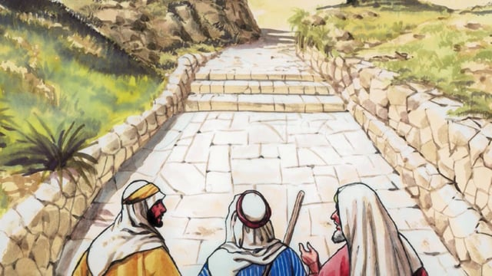

The Journey to Emmaus
Luke 24:13-35

Now that very same day, two of them were on their way to a village called Emmaus, seven miles from Jerusalem, and they were talking together about all that had happened. And it happened that as they were talking together and discussing it, Jesus himself came up and walked by their side; but their eyes were prevented from recognizing him.

He said to them, “What are all these things that you are discussing as you walk along?” They stopped their faces downcast. Then one of them, called Cleopas, answered him, “You must be the only person staying in Jerusalem who does not know the things that have been happening there these last few days.” He asked, “What things?” They answered, “All about Jesus of Nazareth, who showed himself a prophet powerful in action and speech before God and the whole people; and how our chief priests and our leaders handed him over to be sentenced to death, and had him crucified. Our own hope had been that he would be the one to set Israel free. And this is not all: two whole days have now gone by since it all happened; and some women from our group have astounded us: they went to the tomb in the early morning, and when they could not find the body, they came back to tell us they had seen a vision of angels who declared his was alive. Some of our friends went to the tomb and found everything exactly as the women had reported, but of him they saw nothing.”

Then he said to them, “You foolish men! So slow to believe all that the prophets have said! Was it not necessary that the Christ should suffer before entering into his glory?” Then, starting with Moses and going through all the prophets, he explained to them the passages throughout the scriptures that were about himself.

When they drew near to the village to which they were going, he made as if to go on; but they pressed him to stay with them saying, “It is nearly evening, and the day is almost over.” So he went in to stay with them. Now while he was with them at table, he took the bread and said the blessing; then he broke it and handed it to them. And their eyes were opened and they recognized him; but he had vanished from their sight. Then they said to each other, “Did not our hearts burn within us as he talked to us on the road and explained the scriptures to us?” They set out that instant and returned to Jerusalem. There they found the Eleven assembled together with their companions, who said to them, “The Lord has indeed risen and has appeared to Simon.” Then they told their story of what had happened on the road and how they had recognized him at the breaking of bread.

El viaje a Emaús
Lucas 24: 13-35
Ese mismo día, dos de ellos se dirigían a un pueblo llamado Emaús, a siete millas de Jerusalén, y estaban hablando juntos de todo lo que había sucedido. Y aconteció que mientras estaban hablando y discutiendo, Jesús mismo subió y caminó a su lado; Pero sus ojos se vieron impedidos de reconocerlo.
Él les dijo: "¿Qué son todas estas cosas que están discutiendo mientras caminan?" Ellos pararon sus caras abatidas. Entonces uno de ellos, llamado Cleofas, le respondió: "Tú debes ser la única persona que permanezca en Jerusalén, que no sabe lo que ha estado sucediendo en estos últimos días". Él preguntó: "¿Qué cosas? Todo acerca de Jesús de Nazaret, que se mostró un profeta poderoso en la acción y el discurso ante Dios y todo el pueblo; Y cómo nuestros principales sacerdotes y nuestros líderes le entregaron para ser condenado a muerte, y lo crucificaron. Nuestra propia esperanza había sido que él sería el que liberaría a Israel. Y esto no es todo: dos días enteros han pasado ya que todo sucedió; Y algunas mujeres de nuestro grupo nos han asombrado: fueron al sepulcro a primera hora de la mañana y cuando no pudieron encontrar el cadáver, regresaron para decirnos que habían visto una visión de ángeles que declaraban que estaba vivo. Algunos de nuestros amigos fueron a la tumba y encontraron todo exactamente como las mujeres habían informado, pero de él no vieron nada.
Entonces les dijo: "¡Hombres tontos! ¡Tan lentos para creer todo lo que los profetas han dicho! ¿No era necesario que el Cristo sufriera antes de entrar en su gloria? "Entonces, comenzando con Moisés y pasando por todos los profetas, les explicó los pasajes a través de las escrituras que estaban sobre sí mismo.
Cuando se acercaron a la aldea a la que iban, hizo como si continuara; Pero le presionaron para que se quedara con ellos diciendo: "Ya es casi de noche, y el día está casi terminado." Así que entró a quedarse con ellos. Mientras él estaba con ellos a la mesa, tomó el pan y dijo la bendición; Luego lo rompió y se los entregó. Y sus ojos se abrieron y le reconocieron; Pero él había desaparecido de su vista. Entonces se dijeron el uno al otro: "¿No ardía nuestro corazón en nosotros cuando nos hablaba en el camino y nos explicaba las Escrituras?" Ellos salieron en ese instante y regresaron a Jerusalén. Allí encontraron a los Once congregados junto a sus compañeros, quienes les dijeron: "El Señor se ha levantado y se ha aparecido a Simón". Entonces contaron su historia de lo que había sucedido en el camino y cómo lo habían reconocido en el rompimiento de pan.

